# **MORE QUERIES ON BANK DATABASE**

**Question**

(**Week4**)

Branch (branch-name: String, branch-city: String, assets: real)

BankAccount(accno: int, branch-name: String, balance: real)

BankCustomer (customer-name: String, customer-street: String,

customer-city: String)

Depositer(customer-name: String, accno: int)

loan (loan-number: int, branch-name: String, amount: real)

1.Create the above tables by properly specifying the primary keys and the foreignkeys.

2.Enter at least five tuples for each relation.

3.Find all the customers who have an account at all the branches located in a specific city (Ex. Delhi).

4.Find all customers who have a loan at the bank but do not have an account.

5.Find the names of all branches that have greater assets than all branches located in

Bangalore.

6.Demonstrate how you delete all account tuples at every branch located in a specific city

**Schema diagram:**

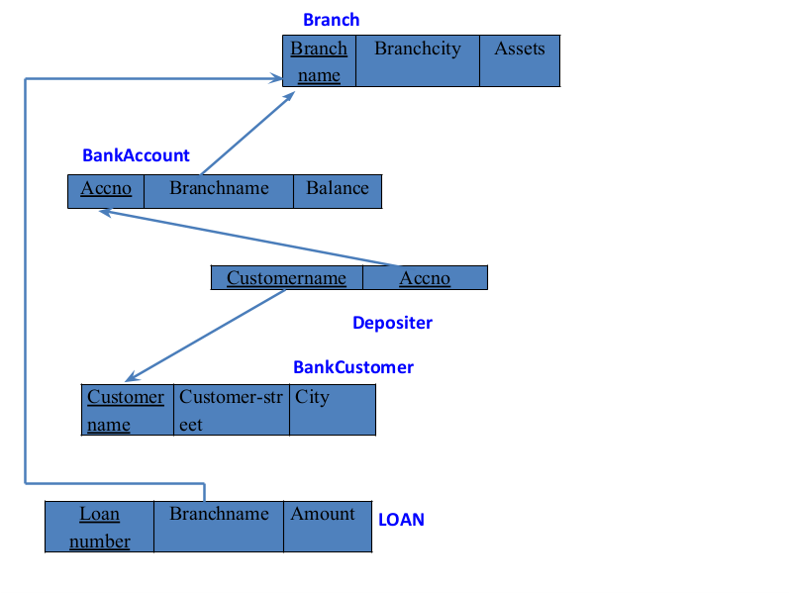

**Create database**

create database bank1;

use bank1;

**create table**

create table branch (

branch_namevarchar(25),

branch_cityvarchar(15),

assets int,

primary key (branch_name)

);

create table bank_account (

accno int,

branch_namevarchar(25),

balance int,

primary key (accno),

foreign key (branch_name) references branch(branch_name)

);

create table bank_customer (

customer_namevarchar(10),

customer_streetvarchar(25),

customer_cityvarchar(15),

primary key (customer_name)

);

create table depositer (

customer_namevarchar(10),

accno int,

primary key(customer_name, accno),

foreign key (customer_name) references bank_customer(customer_name),

foreign key(accno) references bank_account(accno)

);

create table loan (

loan_number int,

branch_namevarchar(25),

amount int,

primary key (loan_number),

foreign key (branch_name) references branch(branch_name)

);

**Structure of the table**

DESC bank_account;

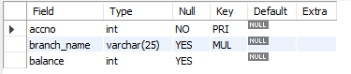

DESC branch;

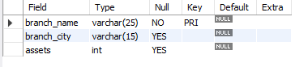

DESC bank_customer;

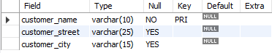

DESC depositer;



DESC loan;

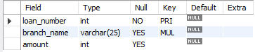

**Inserting values to the table**

insert into branch values('SBI_Chamrajpet', 'Bangalore', 50000);

insert into branch values('SBI_ResidencyRoad', 'Bangalore', 10000);

insert into branch values('SBI_ShivajiRoad', 'Bombay', 20000);

insert into branch values('SBI_ParliamentRoad', 'Delhi', 10000);

insert into branch values('SBI_Jantarmantar', 'Delhi', 20000);

select * from branch;

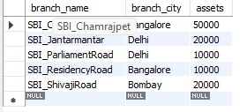

insert into bank_accountvalues(1, 'SBI_Chamrajpet', 2000);

insert into bank_accountvalues(2, 'SBI_ResidencyRoad', 5000);

insert into bank_accountvalues(3, 'SBI_ShivajiRoad', 6000);

insert into bank_accountvalues(4, 'SBI_ParliamentRoad', 9000);

insert into bank_accountvalues(5, 'SBI_Jantarmantar', 8000);

insert into bank_accountvalues(6, 'SBI_ShivajiRoad', 4000);

insert into bank_accountvalues(8, 'SBI_ResidencyRoad', 4000);

insert into bank_accountvalues(9, 'SBI_ParliamentRoad', 3000);

insert into bank_accountvalues(10, 'SBI_ResidencyRoad', 5000);

insert into bank_accountvalues(11, 'SBI_Jantarmantar', 2000);

select * from bank_account;

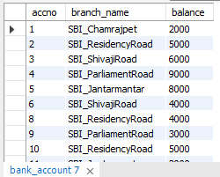

insert into bank_customer values ('Avinash', 'Bull_Temple_Road', 'Bangalore');

insert into bank_customer values ('Dinesh', 'Bannergatta_Road', 'Bangalore');

insert into bank_customer values ('Mohan', 'National_College_Road', 'Bangalore');

insert into bank_customer values ('Nikhil', 'Akbar_Road', 'Delhi');

insert into bank_customer values ('Ravi', 'Prithviraj_Road', 'Delhi');

select * from bank_customer;

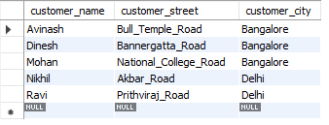

insert into depositervalues('Avinash', 1);

insert into depositervalues('Dinesh', 2);

insert into depositervalues('Nikhil', 4);

insert into depositervalues('Ravi', 5);

insert into depositervalues('Avinash', 8);

insert into depositervalues('Nikhil', 9);

insert into depositervalues('Dinesh', 10);

insert into depositervalues('Nikhil', 11);

select * from depositer;

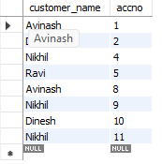

insert into loan values(1, 'SBI_Chamrajpet', 1000);

insert into loan values(2, 'SBI_ResidencyRoad', 2000);

insert into loan values(3, 'SBI_ShivajiRoad', 3000);

insert into loan values(4, 'SBI_ParliamentRoad', 4000);

insert into loan values(5, 'SBI_Jantarmantar', 5000);

select * from loan;

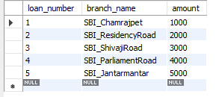

**Queries**

1).Find all the customers who have an account at all the branches located in a specific city(Ex. Delhi).

Select distinct d.customer_name

from depositerd,bank_accountba,branch b

where d.accno=ba.accno and b.branch_name=ba.branch_name and b.branch_city="delhi"

group by d.customer_name having count(b.branch_name)>1;

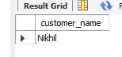

2).Find all customers who have a loan at the bank but do not have an account.

SELECT customer_name

FROM bank_customer

WHERE customer_name IN (SELECT branch_name FROM loan)

AND customer_name NOT IN (SELECT customer_name FROM depositer);

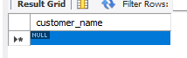

3).Find the names of all branches that have greater assets than all branches located inBangalore.

select branch_name from BRANCH where assets > all (select assets from branch

where branch_city = 'Bangalore');

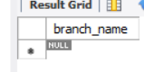

4).Demonstrate how you delete all account tuples at every branch located in a specific city (Ex. Bombay)

delete from bANK_ACCOUNT

where branch_name in (

select branch_name from branch

where branch_city = 'Bombay');

SELECT * FROM bANK_ACCOUNT;

